Refugees and migrants NGO Forum
Date: April 11-12, 2016
Place: Zygmunt Hübner Powszechny Theatre, Warsaw, Poland
Organisers: Stefan Batory Foundation
The Forum is organized under the Citizens for Democracy Programme financed by EEA Grants.
FORUM DESCRIPTION
The Forum targets representatives of non-governmental organisations and informal groups working to support the integration of refugees and migrants: the knowledgeable and experienced and those who are less experienced in this field. The representatives of public institutions are welcome as well, especially local governments co-operating with non-governmental organisations in the area of refugee and migrant integration.
We wish for the Forum to become a place where individuals, who face the challenges of working to support refugees and migrants in practice, can meet and develop a community. We hope that over the next two days, we will be able to create space for inspiring conversations, and for an exchange of knowledge and experience – about what works and what doesn’t, what we are proud of and what has failed, what challenges we usually encounter in our work and how we can try to overcome them. We wish to contribute indirectly improving the quality of work integrating refugees and migrants, to consolidate the community of organisations active in the area: organisations supporting one another in professional efforts and motivating one another to further work.

LANGUAGE

Plenary and workshop sessions (Monday-Tuesday): Participants will be provided with a cabin simultaneous interpreting.

COSTS

Board and lodging as well as flight tickets will be covered by the organizers. Stefan Batory Foundation will arrange participants’ travel from their countries to Warsaw. All meals will be provided (except dinners on April 10th and 12th).

ACCOMMODATION

The organizers will arrange and cover your accommodation for April 10th-12th (up to three nights) in Ibis Stare Miasto (Old Town) Hotel in Warsaw. Participants will be accommodated in single rooms. Breakfast is included. Towels and bed linen are provided.
Note: The organizers will not provide any accommodation for additional stay in Warsaw. If participants plan to arrive a few days earlier or depart a few days later they are kindly requested to arrange their accommodation individually.
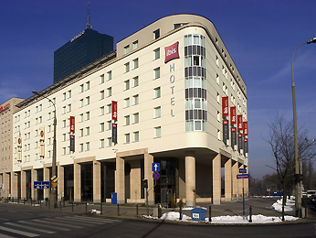

Arrival day: 10th of April
Departure day: 12th/1t3h of April (hotel check out time: 12:00)
Hotel Ibis – Warsaw Old Town
Muranowska 2 Street, Warsaw
tel. : (+48)22-3101000
email: H3714@accor.com

HOW TO GET THERE:
From Warsaw Chopin Airport
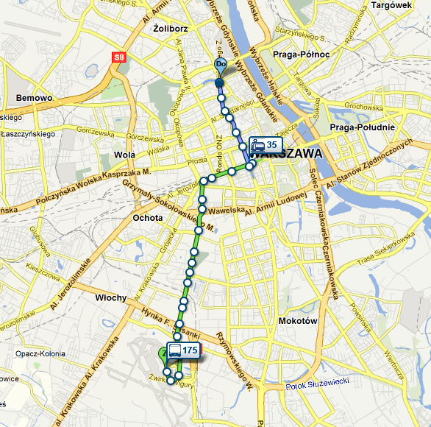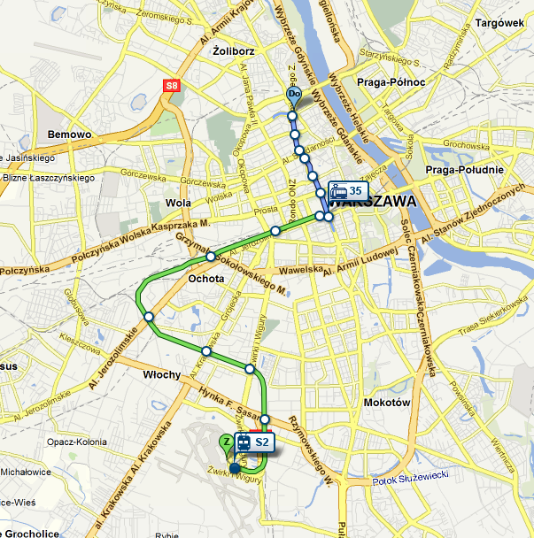
Directions:
Step 1: take a bus No 175 from the Chopin Airport to Warszawa Centrum
(OR take a city train S2 from the Chopin Airport to Warszawa Śródmieście)
Step 2: take a tram No 35, 4 or 15 from Warszawa Centrum and get off at Muranowska tram stop
Duration: 50 min.
If you decide to take a taxi, please remember to ask the driver for the receipt. The taxi from the airport should costs approx. 60 PLN (around 15 EUR).
The currency of Poland is Polish Zloty (PLN).
1 EUR = 4,40 PLN
FORUM VENUE

The Forum will be held in Zygmunt Hübner Powszechny Theatre.

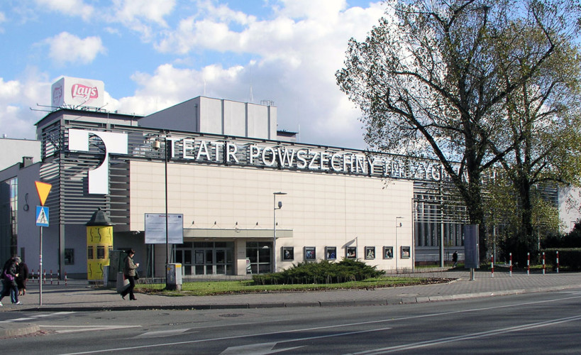
Zygmunt Hübner Powszechny Theatre
20 Jan Zamoyski Street, Warsaw

HOW TO GET HERE:
From the Ibis Stare Miasto (Old Town) Hotel:
Step 1: take tram no 15, 18 or 35 from MURANOWSKA stop, get off at METRO ŚWIĘTOKRZYSKA;
duration: 12 min.
Step 2: take metro M2 from METRO ŚWIĘTOKRZYSKA, get off at STADION NARODOWY.
duration: 11 min.

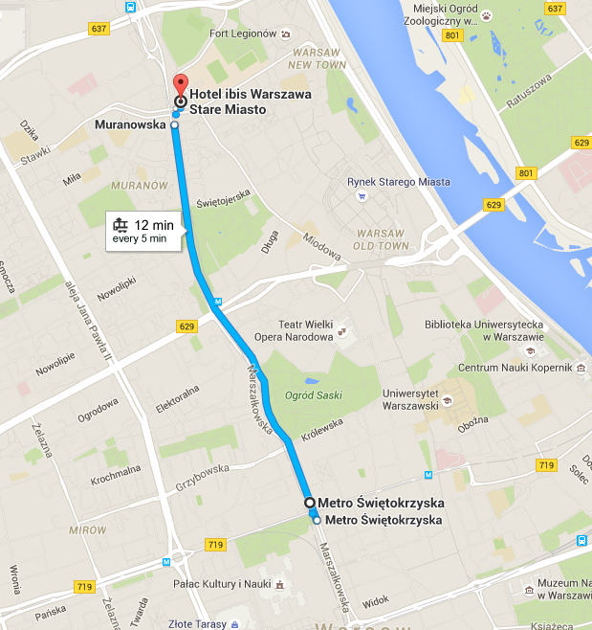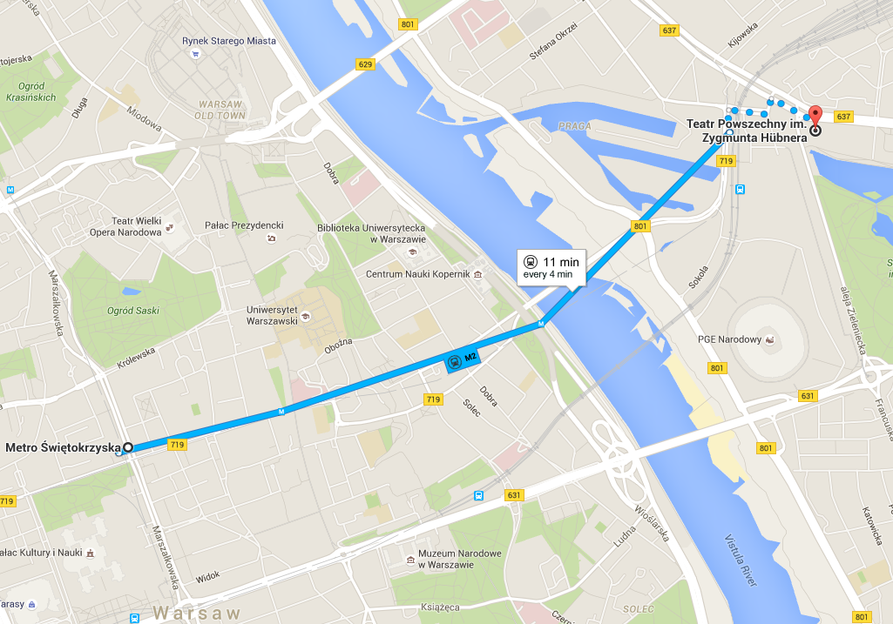

PUBLIC TRANSPORT IN WARSAW

If you plan to use public transport (bus, trams, subway and SKM trains) from/to the airport to/from the hotel, you can buy the following tickets (standard fare):
- single fare transfer ticket (zone 1) entitles to an unlimited number of journeys for a period not exceeding 75 minutes from its validation (4,40 PLN)
Don’t forget to validate your ticket in one of the yellow validators immediately after you start your journey.

CONTACT
In case of any questions, please do not hesitate to contact us:
Agata Szypulska: aszypulska@batory.org.pl, tel. (48 22) 536 02 55, Stefan Batory Foundation.

